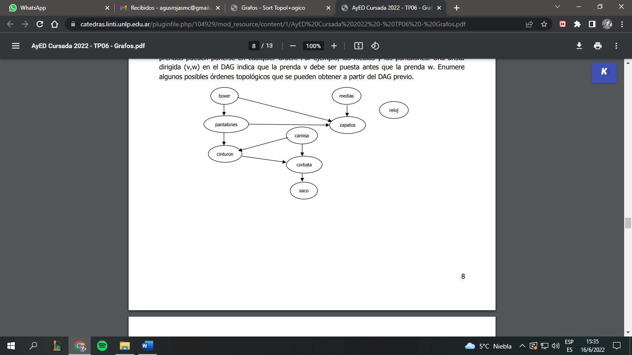

Versión 1

|  |  |  |  |  |  |  |  |  |
| --- | --- | --- | --- | --- | --- | --- | --- | --- |
| BOXER | MEDIAS | RELOJ | PANTALONES | ZAPATOS | CINTURON | CAMISA | CORBATA | SACO |
| 0 | 0 | 0 | 1 | 3 | 2 | 0 | 2 | 1 |
| 0 | 0 | 0 | 0 | 2 | 2 | 0 | 2 | 1 |
| 0 | 0 | 0 | 0 | 1 | 2 | 0 | 2 | 1 |
| 0 | 0 | 0 | 0 | 1 | 2 | 0 | 2 | 1 |
| 0 | 0 | 0 | 0 | 0 | 1 | 0 | 2 | 1 |
| 0 | 0 | 0 | 0 | 0 | 1 | 0 | 2 | 1 |
| 0 | 0 | 0 | 0 | 0 | 0 | 0 | 1 | 1 |
| 0 | 0 | 0 | 0 | 0 | 0 | 0 | 0 | 1 |
| 0 | 0 | 0 | 0 | 0 | 0 | 0 | 0 | 0 |

SORT TOPOLOGICO: BOXER, MEDIAS, RELOJ, PANTALONES, ZAPATOS, CAMISA, CINTURON, CORBATA, SACO

Versión 2

|  |  |  |  |  |  |  |  |  |  |
| --- | --- | --- | --- | --- | --- | --- | --- | --- | --- |
|  | BOXER | MEDIAS | RELOJ | PANTALONES | ZAPATOS | CINTURON | CAMISA | CORBATA | SACO |
| 0 | 0 | 0 | 0 | 1 | 3 | 2 | 0 | 2 | 1 |
| 1 | 0 | 0 | 0 | 1 | 3 | 1 | 0 | 1 | 1 |
| 2 | 0 | 0 | 0 | 1 | 3 | 1 | 0 | 1 | 1 |
| 3 | 0 | 0 | 0 | 1 | 2 | 1 | 0 | 1 | 1 |
| 4 | 0 | 0 | 0 | 0 | 1 | 1 | 0 | 1 | 1 |
| 5 | 0 | 0 | 0 | 0 | 0 | 0 | 0 | 1 | 1 |
| 6 | 0 | 0 | 0 | 0 | 0 | 0 | 0 | 0 | 1 |
| 7 | 0 | 0 | 0 | 0 | 0 | 0 | 0 | 0 | 0 |
| 8 | 0 | 0 | 0 | 0 | 0 | 0 | 0 | 0 | 0 |
| 9 | 0 | 0 | 0 | 0 | 0 | 0 | 0 | 0 | 0 |

PILA:

1. BOXER, MEDIAS, RELOJ, CAMISA
2. BOXER, MEDIAS, RELOJ
3. BOXER, MEDIAS
4. BOXER
5. PANTALONES
6. ZAPATOS, CINTURON
7. ZAPATOS, CORBATA
8. ZAPATOS, SACO
9. ZAPATOS

SORT TOPOLOGICO: CAMISA, RELOJ, MEDIAS, BOXER, PANTALONES, CINTURON, CORBATA, SACO, ZAPATOS

Versión 3 Opción b



PILA: SACO, CORBATA, CINTURON, ZAPATOS, PANTALONES, BOXER, CAMISA, MEDIAS, RELOJ.

SORT TOPOLOGICO: RELOJ, MEDIAS, CAMISA, BOXER, PANTALONES, ZAPATOS, CINTURON, CORBATA, SACO